
CENTER FOR JUSTPEACE IN ASIA
96 Pak Tin Village, Area 2
Mei Tin Road, Sha Tin]
N.T., Hong Kong S.A.R.
Tel: 852-2697-1917
EMail: justpeace@daga.org.hk
Web: http://daga.dhs.org/justpeace
Vol: 1 No. 4
February, 2003

This is a special issue of Justpeace News to highlight various activities being organized around Asia and the world to speak out against the threat of war on Iraq and call for a global movement to make use of the vast resources, wisdom, education and skill available globally to find a better way than war to settle disputes. It is indeed sad that in a world with such a vast amount of creativity, experience, goodwill and wisdom, people still resort to throwing very deadly and lethal sticks and stones when they can not agree with each other. It is our hope that these actions now being done to prevent a war on Iraq will continue well into the future so that there will be less and less need for the destructive weapons of mass destruction now being stockpiled by the world's superpowers.

Please share your own plans and creative actions for peace with us and we will include them in our next Justpeace News.

World Student Christian Federation (WSCF)

Two important activities have been initiated by the WSCF in response to the growing threat of war. The first is a postcard campaign. The cards proclaim, "Give Chance to Peace!" and are addressed to President George Bush. All you need to do is sign and add a stamp. These cards can be ordered from WSCF at wscfap@netvigator.com.

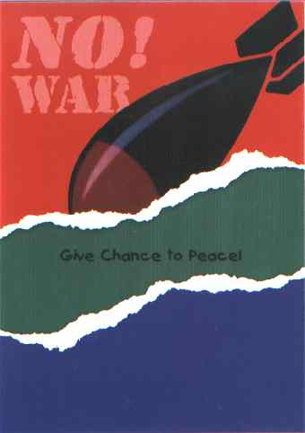 | 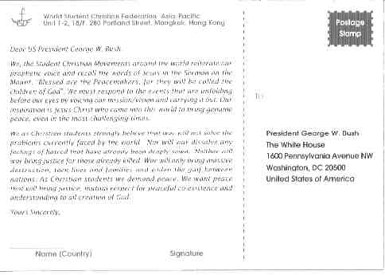

Secondly the WSCF has launched a "Skipping Meals" campaign. The staff in their Hong Kong office have pledged to skip lunch every Tuesday and save this money for the children in Iraq. They call on friends around the world to join them in this campaign. They plan to continue the campaign for at least 40 days. Once the funds from the campaign are collected, WSCF will contact their office in the Middle East to arrange for the money to be used to assist children in Iraq.

About 500,000 children have died horrible deaths as a result of the sanctions and the depleted uranium left behind during the gulf war. If another war breaks out, millions of people, particularly children, will suffer.

Please join WSCF in this campaign by skipping at least one meal each week and pooling the money for the children of Iraq!

You can learn more about WSCF at their web-site http://www.wscfap.org

Canada

A group in Canada has initiated a program to seriously inspect countries that produce, sell and have used in the past, weapons of mass destruction. The first country in which they are carrying out their inspections is the United States. Read more about their work at http://www.rootingoutevil.org./.

Thailand

In Thailand various groups have formed the United for Peace Coalition. Members of the coalition include the Coalition of Inter-Religious Groups, Center of Muslim Communities in Thailand, a Buddhist monk from Sekhiya Dhamma, Asia Forum, Artists Network for Peace and several groups from local NGOs.

Their plan:

27 Jan - The United for Peace, Thailand will gather in front of the UN office in Bangkok and present a letter demanding that the UN lead the world to peace and oppose the possible war on Iraq. Here they will also produce a "Live Poster" entitled "Disarm America." A live poster is one that is produced at the public rally, providing people watching or passing by an opportunity to participate and share their concerns. Producing a "Live Poster" makes the rally much more exciting and active. A silk screen is also present at the rally so that the poster produced can immediately be printed onto people's t-shirts, paper, etc.

28 Jan - The group will present a letter to the Thai Government and the Speakers of the Parliament. A "Live Poster" with a different theme will be presented here.

On going plans include:

United for Peace will hold day to day campaigns around university campuses as well as community parks in Bangkok and nearby vicinities.

Artists for Peace task force will continue it's free T-shirt and poster printing on site for people who need them. (People can bring T-shirts and paper for the group to print on).

People can also down load posters from the website <www.carefor.org>, as well as other public website interventions.

Groups of street musicians and performing groups will go on the streets around Bangkok for several weekends beginning the first weekend of February.

Other activities are being discussed and will be shared with the Center for Justpeace in Asia later.

USA

Here is a simple action for peace we can all take: sending rice to the president to send to Iraq instead of bombs. Note the historical precedent for this action.

Place 1/2 c. uncooked rice in a small plastic bag (a snack-sized bag or a sandwich bag works fine) Squeeze out excess air and seal the bag. Wrap it in a piece of paper on which you have written:

"If your enemies are hungry, feed them. Romans 12:20. Please send this rice to the people of Iraq; do not attack them."

Place the paper and bag of rice in an envelope and address them to:

President George Bush White House
1600 Pennsylvania Ave.
NW Washington, DC 20500
USA

Drop this in the mail TODAY. It is important to act NOW so that President Bush gets the letters asap.

In order for this protest to be effective, there must be hundreds of thousands of such rice deliveries to the White House. We can do this if we all forward this message to our friends and family.

There is a positive history of this peacemaking action! Read on!

"In the mid 1950s, the Fellowship of Reconciliation, learning of famine in the Chinese mainland, launched a "Feed Thine Enemy" campaign. Members and friends mailed thousands of little bags of rice to the White House with a tag quoting the Bible, "If thine enemy hunger, feed him." As far as anyone knew for more than ten years, the campaign was an abject failure. The President did not acknowledge receipt of the bags publicly; certainly no rice was ever sent to China.

"What nonviolent activists only learned a decade later was that the campaign played a significant, perhaps even determining role in preventing nuclear war. Twice while the campaign was on, President Eisenhower met with the Joint Chiefs of Staff to consider US options in the conflict with China over two islands, Quemoy and Matsu. The generals twice recommended the use of nuclear weapons. President Eisenhower each time turned to his aide and asked how many little bags of rice had come in. When told they numbered in the tens of thousands, Eisenhower told the generals that as long as so many Americans were expressing active interest in having the US feed the Chinese, he certainly wasn't going to consider using nuclear weapons against them."

